**Problem Analysis (TO-BE)**

|  |  |  |  |  |
| --- | --- | --- | --- | --- |
| **Process Name** | **Stakeholders** | **Concern (Problems)** | **Analysis (reason of the problem)** | **Proposed Solutions** |
| Course  Assessment  Report | Instructor /  Course  Coordinator | Sending hardcopy  And softcopy  Students examination marks  And course  Assessment report  To the register office store the info  Time consumption  And delay is prime limitation. | As sending hardcopy and softcopy to the register office involve multiple  persons and different  processes, it could  easily led to confusion, loss of  important student report card. | Can be uploaded by IRAS by the faculty and viewed by interested  Persons. |
| Department should be able to see individual instructor performance | Department Head  Instructor | Instructor send the hardcopy of the semester wise student performance report to the department head | Department head need to know how students are performing under a specific instructor and whether the instructors are following the rules given by the head of department. hardcopy is time consuming and not so informative | We can create an option in IRAS where department head will be able to see course wise students’ performance by an instructor |
| |  | | --- | | instructor will be able view the semester wise CGPA and grades of a student | | Instructor  IRAS | Instructor don’t get to see  Result of a student from their previous semester | It becomes difficult for an instructor to monitor students | There will be an option in IRAS where the instructor will be able to see semester wise performance of students who enrolled in his course. |
| UGC approves  curriculum  based on PLO and CO | 1. Higher  Management (HM)  2. UGC | 1. HM needs to send the curriculum  booklet manually.  2. HM needs to send the updated  Curriculum to the  Department every time. | 1. It will take time for the UGC to receive the Curriculum booklet and process the information.  2. It is a hassle to send manually every time the curriculum is updated | We can transfer the  curriculum in our  software by which it could be accessed  easily by the members and it also could be edited real time by the HM and updated instantly whenever changes are required by the UGC. |
| CO Entry and Mapping | 1. IUB Faculties  2. Admin | 1. Faculties mapped  each PLO to COs for each course and send it to the Admin  2. Admin receives  updated COs and  update it to the excel database | They might be subjected to change each semester depending on the course question pattern etc. The process is time consuming as well as the faculties have to send the mapped COs to the Admin and wait for the update | SPM already contains the PLOs so the faculties can  directly map the Cos from their own account |

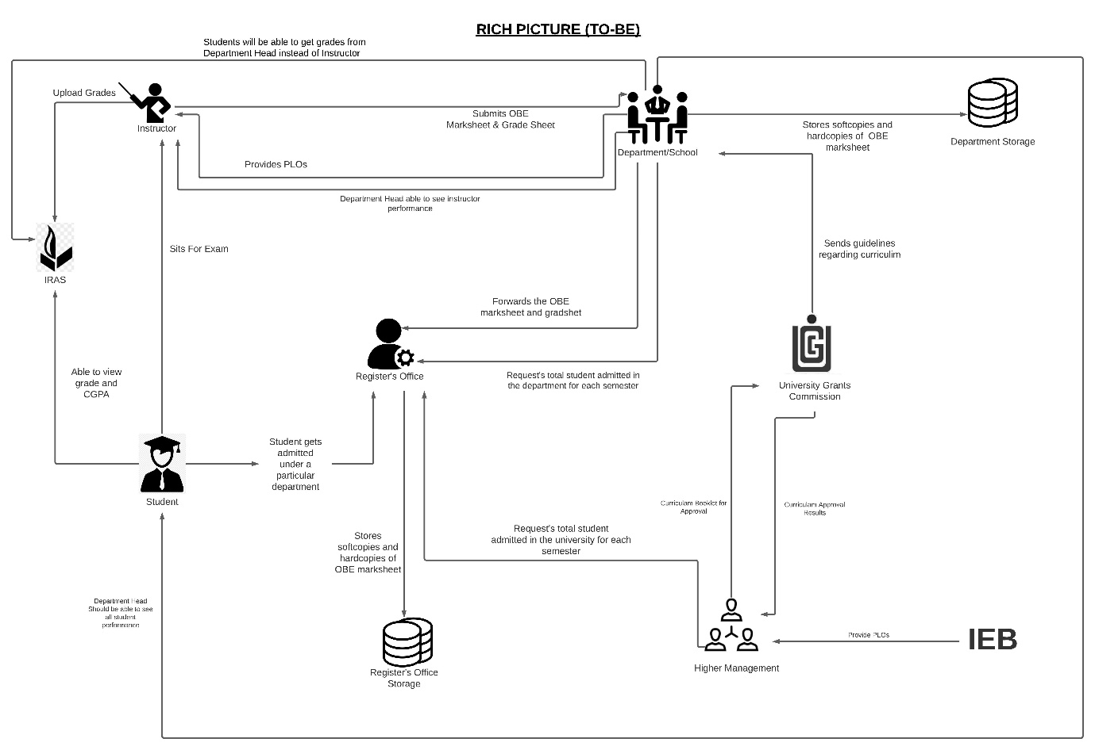

|  |  |  |  |  |  |  |
| --- | --- | --- | --- | --- | --- | --- |
| **Process** | **System Process** | | | | | |
| **Human** | **Non-comb Hardware** | **Computing Hardware** | **Software** | **Database** | **Network and Communication** |
| **Instructor Able to see the result of another courses of a Student** | **Instructor:**  1.Login to IRAS.  2. Search that specific student's id.  3. See the grades of other courses for intended semester.  **Register Office:**  1.Access IRAS.  2.View Students grades of other courses if and when it’s necessary. | **Pen and Paper:**  Note down the grade if needed. | **Computer/Phone:**  1.Used for accessing IRAS.  2.Used Computer to make softcopies.  **Printer:**  Printout the softcopies. | **IRAS:**  1.Stores letter grades of each completed course.  2.Provides the online user interface for viewing grades.  **Networking devices (Router, Switch Bridge, Hub):**  Used by Instructor and students to access the Internet. | **IRAS Database Server:**  Instructor receive the student information in IRAS. | **Internet:**  All related data searched through internet. |
| **Students will be able to get grades from Department instead of Instructor** | **Department:**  1.Collect the student’s marks sheet.  2.Login to IRAS.  3.Search a Student I’d to upload his/her grade.  3.Select a particular course.  4. Submit the grade next to the student’s name. | **Calculator:**  Marks are calculated with a calculator. | **Computer:**  Used for accessing IRAS.  **Printer:**  Printout the softcopy of the mark sheet. | **Excel sheet:**  Marks-sheet can be created using Excel sheet, Google sheet  **Email Software:**  Used for communication between Department head and Instructor. | **IRAS Database server:**  1. IRAS uses a database server to store and maintain student grades’ information | **Internet and Gmail:**  The marks sheet can be taken through emails or any other internet messaging platforms. |
| **Department Head able to see all instructor**  **performance** | **Department:**  1.Login to IRAS.  2.Record mark about instructors and see all the activity. | **Paper:**  Instructor send the hardcopy of the semester wise student performance report to the  Department. | **Computer/Phone:**  1.Used for accessing IRAS.  2.Create softcopies of record of all assessment data  **Printer:**  2.If needed Printout the softcopies. | **Excel sheet:**  Record necessary assessment data in Excel sheet.  **IRAS:**  Update activity of Instructor.  **Printing Software:**  Used for printing Software doc.  **PDF Viewer:**  To view the transcript in PDF-form. | **Department Storage:**  Record of instructor assessment.  **IRAS server:**  Store update activity. | **Internet:**  Need to connect IRAS. |

**Process Diagram (TO-BE)**

